ADITHYA R
192311369

Experiment – 12
Demonstrate virtualization by Installing Type-2 Hypervisor in your device, create and configure VM image with a Host Operating system (Either Windows/Linux), using VMware workstation.
Answer:
AIM: To demonstrate virtualization by installing a Type-2 Hypervisor (VMware Workstation) on a host operating system and creating and configuring a virtual machine with Ubuntu Linux as the guest operating system.
SOFTWARE REQUIRED: VMware Workstation 17, Ubuntu ISO, Host OS: Windows
PROCEDURE:

- VMware Workstation 17 was installed on a Windows host operating system.
- VMware Workstation operates on top of the host OS, confirming it as a Type-2 Hypervisor.
- A new virtual machine was created using the typical configuration option.
- Ubuntu ISO file was selected as the installation media.
- Linux was chosen as the guest operating system with Ubuntu as the version.
- The virtual machine was named and a suitable storage location was selected.
- The virtual machine was created successfully and Ubuntu installation started automatically.

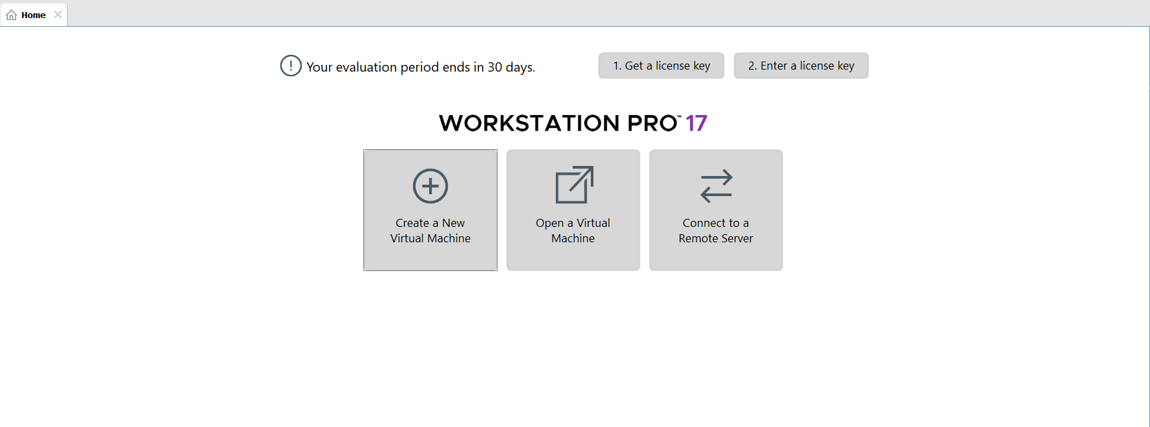
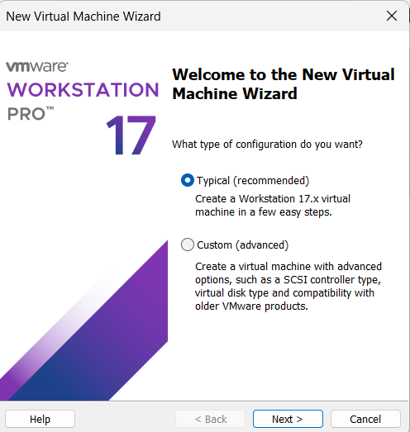

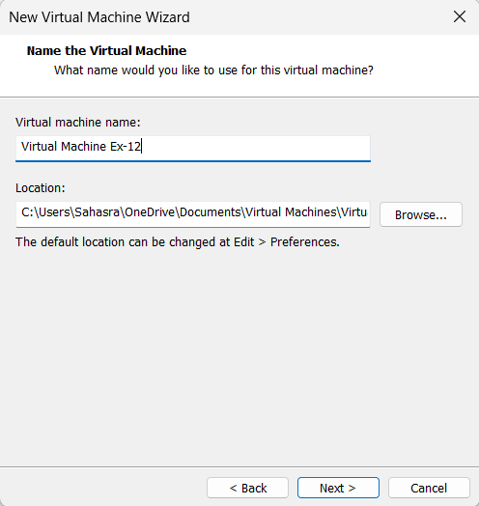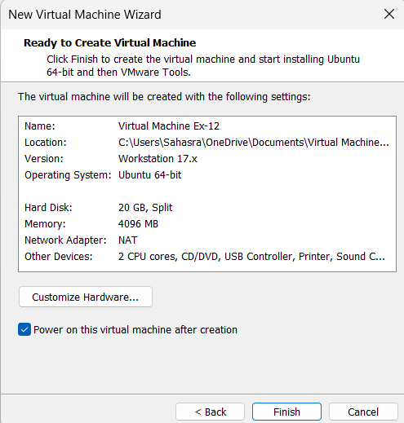

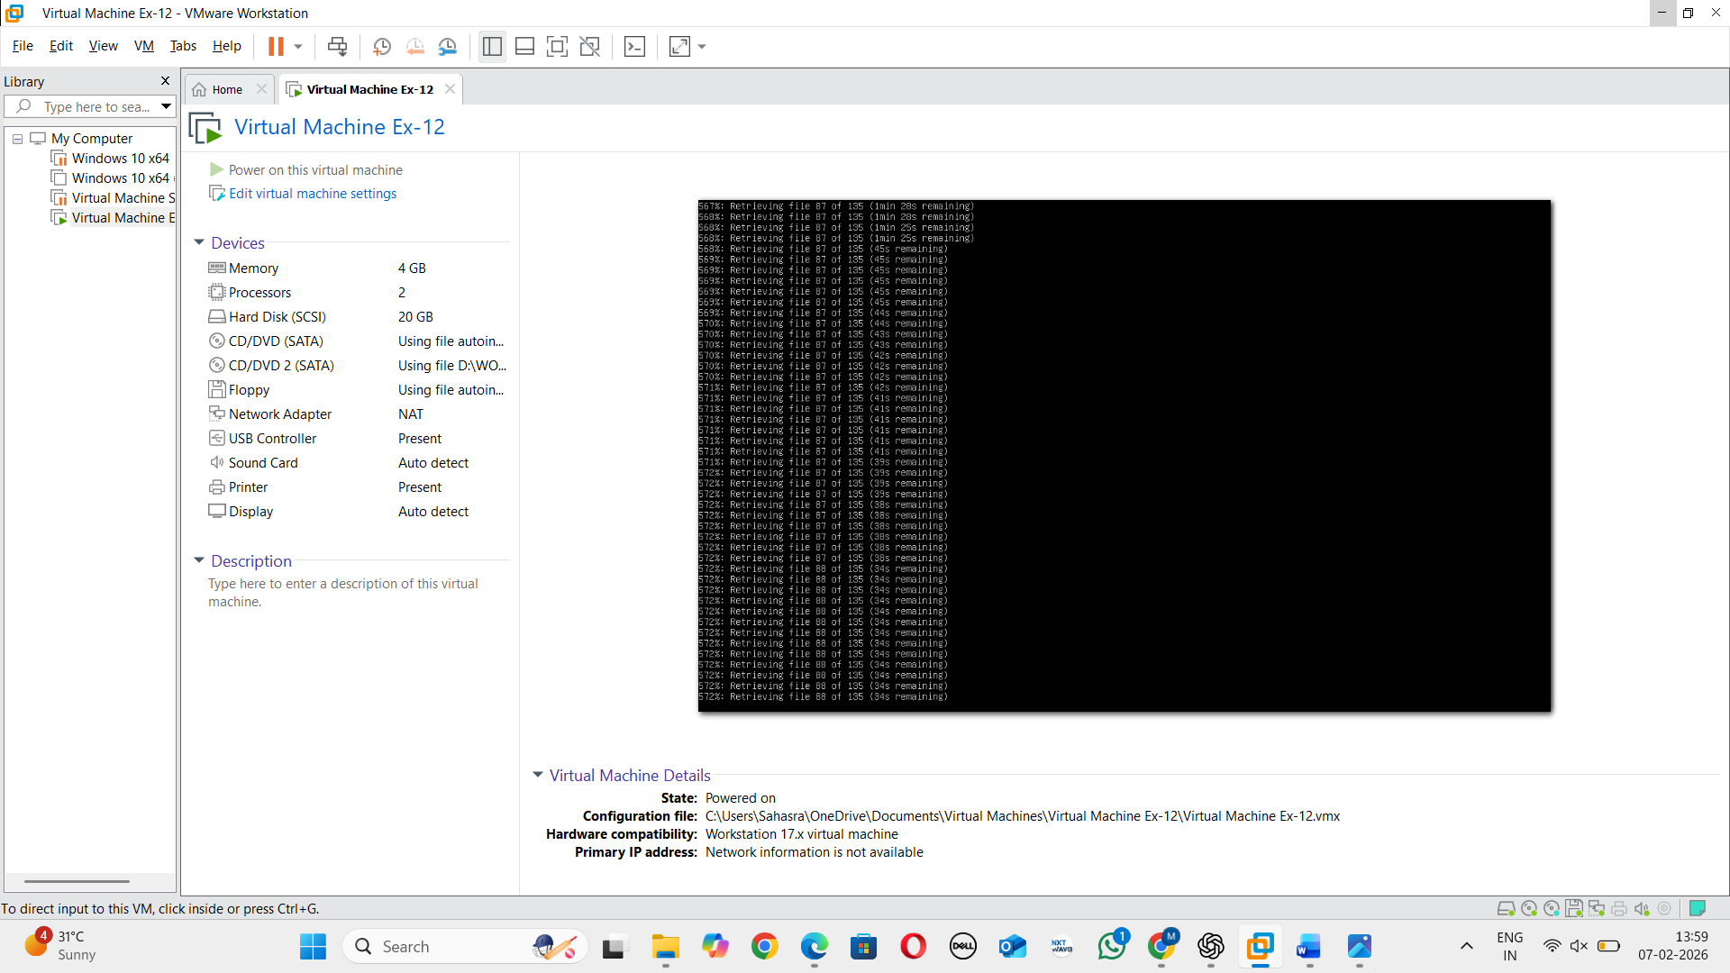
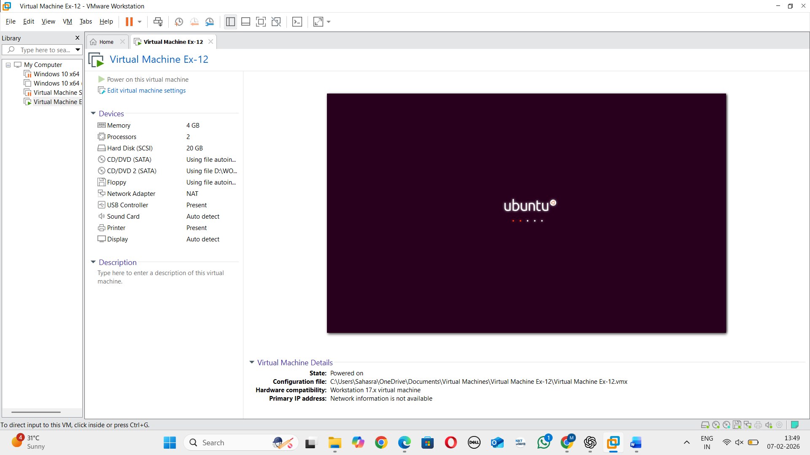

RESULT: Virtualization is successfully demonstrated using VMware Workstation Type-2 Hypervisor.

